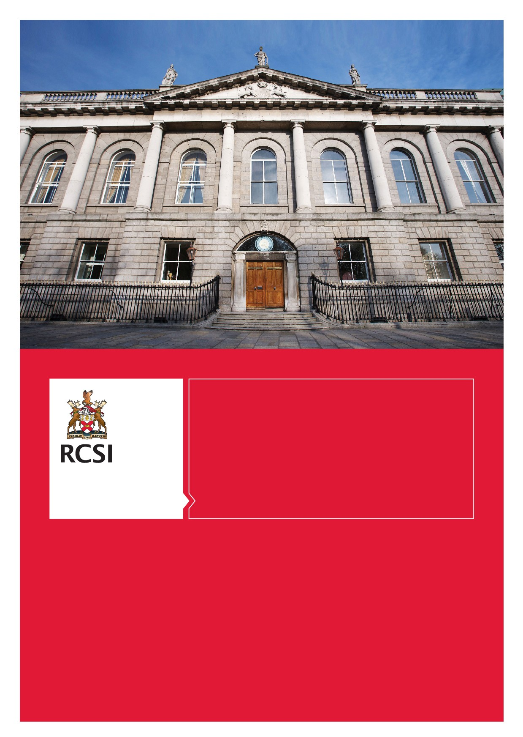

1 | P a g e

Research Lecturer
RCSI Strategic Academic Recruitment (StAR) Programme
Neuroscience

CLOSING DATE: March 23rd 2018

RCSI’s Strategic Academic Recruitment (StAR) Programme is an ambitious initiative to accelerate the delivery of innovative, impactful research in the health sciences. Under the StAR Programme, RCSI prioritises the nurturing of research talent through the commitment of a wealth of resources, all focused on a collegial academic and teaching environment that encourages each RCSI researcher to develop and grow. To coincide with the launch of FutureNeuro, the SFI Research Centre of Excellence for chronic and rare neurological diseases, RCSI is seeking an ambitious, visionary researcher to embark with us on the latest exciting phase in our research mission in neuroscience.

- Job Description

Post Title – Research Lecturer – Neuroscience
Reports to – Head of Department or nominee
Location - FutureNeuro Research Centre, Royal College of Surgeons in Ireland (RCSI), Dublin
Salary and package - The salary for this position is €63,125 until the post is tenured as permanent academic lectureships (3-5 years). In addition, RCSI will make an investment of up to €150,000 in your research, including a 4 year PhD studentship and significant career development investment in the form of mentoring and protected research time. The position provides an opportunity to participate in a team of world-leading neuroscientists in the highly prestigious FutureNeuro Research Centre for Chronic and Rare Neurological Diseases. https://www.futureneurocentre.ie/

Term of office: Tenure track appointment up to 5 years (pending performance review). The applicant will receive a yearly progress review, and at the end of year 3, a major review will be undertaken to determine whether the position will be converted to a permanent post. The review will be overseen by a committee that is external to the Research Lecturer’s academic department.

Neuroscience at RCSI

Up to one billion people worldwide suffer from brain diseases. In Europe, brain diseases represent 35% of the total burden of all disease, affecting 179 million patients and costing more than €800 billion per annum. Neuroscience and genetics research underpinned by remarkable new sequencing and imaging technologies have advanced our understanding of the pathomechanisms of these diseases. Science Foundation Ireland (SFI) has recently funded FutureNeuro – a National SFI Research Centre of Excellence for chronic and rare neurological diseases. FutureNeuro brings together multidisciplinary scientific teams with clinicians and industry to deliver advances in diagnostic medicine, personalized and network therapeutics, cross-linked by a national e-Health infrastructure platform that is disease-focused. The mission of FutureNeuro is to accelerate discoveries on genetic diagnosis and advanced molecular treatments supported by enabling e-health technology for chronic and rare neurological diseases. Building initially on internationally recognized strengths in epilepsy and motor neuron disease research, the Centre aims to develop additional research programmes in other chronic and rare neurological diseases.

RCSI has a significant international track-record in the field of neuroscience. Examples of recent work by RCSI-based teams in the Centre include breakthroughs in uncovering the patho-mechanisms underlying epilepsy development following brain injury, human brain imaging evidence of structural changes in epilepsy patients over time, exploring the role of epigenetics and noncoding RNAs in epilepsy, developing systems modelling and biomarkers in particular those related to the development and treatment of sporadic forms of epilepsy.

The RCSI-based members of the FutureNeuro Centre include:
- Prof David Henshall, FutureNeuro Centre Director, is a world-leading authority on cell death signaling pathways and the role of noncoding RNAs (microRNAs) in epilepsy.
- Prof Jochen Prehn, Chairman of the Department of Physiology and Medical Physics, has pioneered cell imaging and mathematical modeling of neural behavior and co-discovered the ALS risk gene ANG.
- Prof Gianpiero Cavalleri discovered the genetic predictor of serious adverse reactions to the commonly used epilepsy drug carbamazepine and plays a leading role in international pharmacogenomics and genetics consortia.

Other FutureNeuro Centre PIs bring expertise in neuronal stem cell technology (Prof Sanbing Shen NUIG), molecular technology in blood-brain barrier (Prof Matthew Campbell TCD) and advanced detection of brain molecules in blood (Prof Robert Forster, DCU). The PI team is complemented by eminent clinicians in the field of neuroscience - Prof Orla Hardiman and Prof Colin Doherty. Additionally, FutureNeuro is built on network of research active clinical collaborators based in Ireland’s key paediatric and adult specialist centres for treatment of complex neurological diseases.

The FutureNeuro PI outstanding scientific achievements have created international reputations in key fields that underpin the Centre’s research. The Group published over 400 articles between 2010-2016 with over 60 international collaborators that received 7000+ citations including recent work in the highest impact journals in the world: Nature, Science, Nat Genet, Nat Med, Sci Trans Med and New Engl J Med. Members lead international consortia and major European initiatives. Income for 2016 was 35M€. To find out more about RCSI research please review:
http://www.rcsi.ie/files/research/docs/20141104024721_RCSI_Strategy_For_Excellence_I.pdf

FutureNeuro has a mandate to build successful industry partnerships with a view to commercialisation. To date, the center has developed multinational and indigenous partners across the three thematic areas, including its research on genomic interrogation for precision medicine, next-generation therapeutics with multi-targeting and disease-modifying actions and e-Health. FutureNeuro will expand it industry collaborations to scale the Centre and to address other neurological disease areas. Engagement with industry partners is a key element of all research roles.

Objective

As part of the ambitious growth and expansion plans for the Centre, we are seeking an innovative Research Lecturer to join FutureNeuro and complement the existing strengths at RCSI. The College has set a strategic objective to support up-and-coming research leaders to establish world- leading research teams and contribute to the continued development of teaching and world- class research programmes at RCSI.

We are interested in candidates working in any field relevant to brain structure and function and chronic and rare neurological diseases. Research excellence and potential is the primary focus of the recruitment. However, we would particularly welcome applications from individuals working with the following technologies:

- Model organisms (c elegans, drosophila, zebrafish)
- iPS and cerebral organoid research
- Single cell sequencing and/or RNA editing

- Genomic Medicine
- Genetics/Epigenetics
- Application of gene editing technology

The successful candidate must hold a PhD, MD or equivalent in a relevant discipline such as Neuroscience, Biomedical Sciences, Developmental/Cell/Molecular Biology, Computational Biology or related subject.
Candidates must already have demonstrated scientific excellence with clear potential of becoming independent research leaders evident by high impact factor publications, fellowships and awards received.
The successful applicant will be expected to obtain significant research funding, such as a Science Foundation Ireland Career Development Award or a European Research Council Starting Grant. In addition, the applicant is expected to publish in leading high impact journals in their discipline, to supervise PhD students and to participate in undergraduate student teaching and training.

Specifics of the Post
The successful applicant will enter the programme with a 5 year contract and will be linked with a senior academic to provide mentorship. Funding for a PhD student will be provided that may be jointly supervised by their senior academic advisor, along with some funding for consumables (in total, four years of start-up funding). All Research Lecturers will receive considerable evaluation and feedback every year from both their academic advisor and a Research Institute evaluation committee that monitors their progress. At the end of the 3rd year, the Research Lecturer will receive a major evaluation, and those that have had outstanding performance with regard to quality publications and success in obtaining research income that will ensure independent investigator status may be made permanent. During the non-tenure phase of their contract, Research Lecturers will also have the opportunity to provide dedicated contact teaching hours in a supportive environment per semester so that they might begin to develop their teaching skills in advance of a permanent position.

Upon appointment, the Research Lecturer and their academic sponsor will devise a 5 year plan for both research and teaching at RCSI. It is generally expected that in year 1 the Research Lecturer will have protected time to establish their research programme at RCSI, with contribution to teaching within their academic department commencing in year 2, as coordinated and approved by their Head of Department. Support for a 4 year PhD studentship and research including costs (consumables and travel) is provided with the Research Lectureship, and a description of the PhD thesis project should be provided in the 5 year plan. The senior academic advisor may, where appropriate, jointly supervise the PhD student’s thesis.

The 5 year plan will address the following points:

- The research questions and why they are significant and complement/differ from current state of the art research and competitors worldwide;
- The research project of the PhD student;
- Plan for winning leading grants;
- The mechanism by which the academic advisor will assist in achieving success;
- Plan for teaching, commencing in year 2, coordinated and approved by the relevant Head of Department.

The purpose of the career planning exercise is to agree longer term goals (i.e. 5 years) and will be monitored through RCSI’s annual Professional Development Planning (PDP) process.

Profile
We are seeking a candidate with an exceptional track record, demonstrated research leadership, a higher degree in a relevant health-related discipline and must come highly recommended by their peers as a candidate of outstanding ability.

Specific Responsibilities include:
- Establishing a research programme complementary to ongoing research themes aligned with FutureNeuro and the RCSI Research Strategy;
- Participating in the administration and delivery of current teaching programmes, teaching modalities and assessment of undergraduate students;
- Contributing to the development and introduction of new teaching programmes, teaching modalities and modes of assessment;
- Securing funding so as to sustain a research group of postgraduate students and other research staff, with resultant publications in journals of high quality/impact;
- Identifying, promoting and maintaining successful collaborations with academic and industry partners;
- Liaising with colleagues across RCSI international campuses in the facilitation of teaching and research activities;
- Undergoing programmes of training and development as may be required;
- Undertaking overseas assignments as may be required from time to time;
- Performing such other related duties as may be required;
- Representing the best interests of RCSI at all times.

Person Specification:
- Doctoral degree e.g. PhD, MD or equivalent;
- Internationally competitive research record, as evidenced by peer-reviewed publications in journals of high quality/impact, grant support, fellowships and awards received and supervision of postgraduate students;
- Evidence of international reputation through leadership of international societies, editorial boards and conferences would strengthen applications;
- Effective communication style appropriate to audience and situation;
- Strong commitment to own personal and professional development.

Application Process:
Applications should be submitted via www.rcsi.ie/star and should include the following:

- Current CV/resume;
- Completion of the online application form including the contact details of a minimum of two referees.

Interview and presentation
Shortlisted candidates will be invited for a formal panel based interview and presentation at our main campus at RCSI Dublin. Please note the closing date for applications is March 23rd 2018.
Interviews will take place in the month of April.

Informal Enquiries
Informal enquiries are invited in the first instance through Judy Walsh, Human Resources Department on +353 (1) 4022440 or email star@rcsi.ie. Further information is available from www.rcsi.ie/star

